**ASSIGNMENT-1**

SMART HOME AUTOMATION

**Make a Smart Home in Tinkercad, using 2+ sensors, Led, Buzzer in single code and circuit.**

**LINK:** **https://www.tinkercad.com/things/4x7lJmW135b-powerful-kup-esboo/editel**

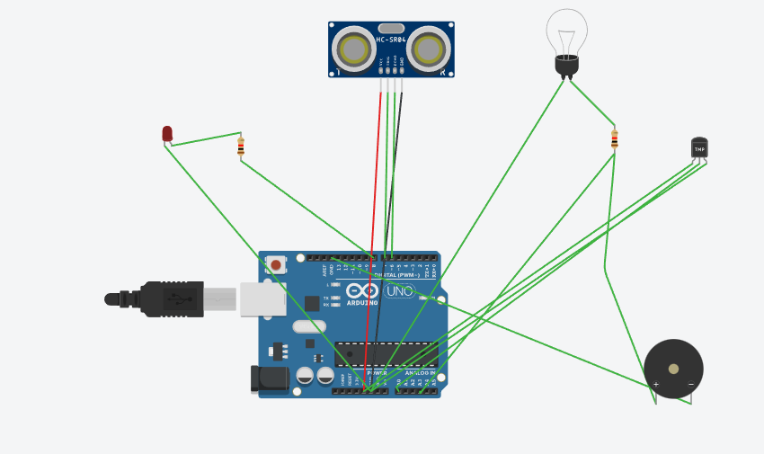

Code:

// C++ code

#define t 7

#define e 6

#define bulb 2

void setup()

{

Serial.begin(9600);

pinMode(t,OUTPUT);

pinMode(e,INPUT);

pinMode(12,OUTPUT);

pinMode(bulb,OUTPUT);

}

void loop()

{

//ultrasonic sensor

digitalWrite(t,LOW);

digitalWrite(t,HIGH);

delayMicroseconds(10);

digitalWrite(t,LOW);

float dur=pulseIn(e,HIGH);

float dis=(dur/2)*0.0343;

Serial.print("Distance is: ");

Serial.println(dis);

if(dis<100){

digitalWrite(bulb,HIGH);

}

else{

digitalWrite(bulb,LOW);

}

double a= analogRead(A0);

double temp=(((a/1024)*5)-0.5)*100;

Serial.print("Temp Value: ");

Serial.println(temp);

delay(1000);

if(temp>=100)

{

digitalWrite(8,HIGH);

}

//LED OFF

if(temp<100)

{

digitalWrite(8,LOW);

}

}